Basic Information
https://github.com/LittleLaGi/nsdhw_21au/tree/LittleLaGi-proposal/proposal/LittleLaGi

Problem to Solve
Multi-objective formulations are realistic models for many complex engineering optimization problems. Objectives under consideration usually conflict with each other. Possible solutions form a Pareto set. A Pareto optimal set is a set of solutions that are non-dominated with respect to each other. We can use multi-objective GA to get a set representing the Pareto optimal set well.
GA is inspired by evolutionary theory. In GA terminology, a solution vector is called an individual or a chromosome, which normally corresponds to a unique solution x in the solution space. GA operates with a collection of chromosomes, called a population. The population is normally randomly initialized. As the search evolves, the population includes ﬁtter solutions, and eventually it converges.
This proposal proposes a project named Oh My Gene(OMG), which provides high-level Python API to construct GA to solve multi-objective problems. Below is a diagram of GA’s general flow:
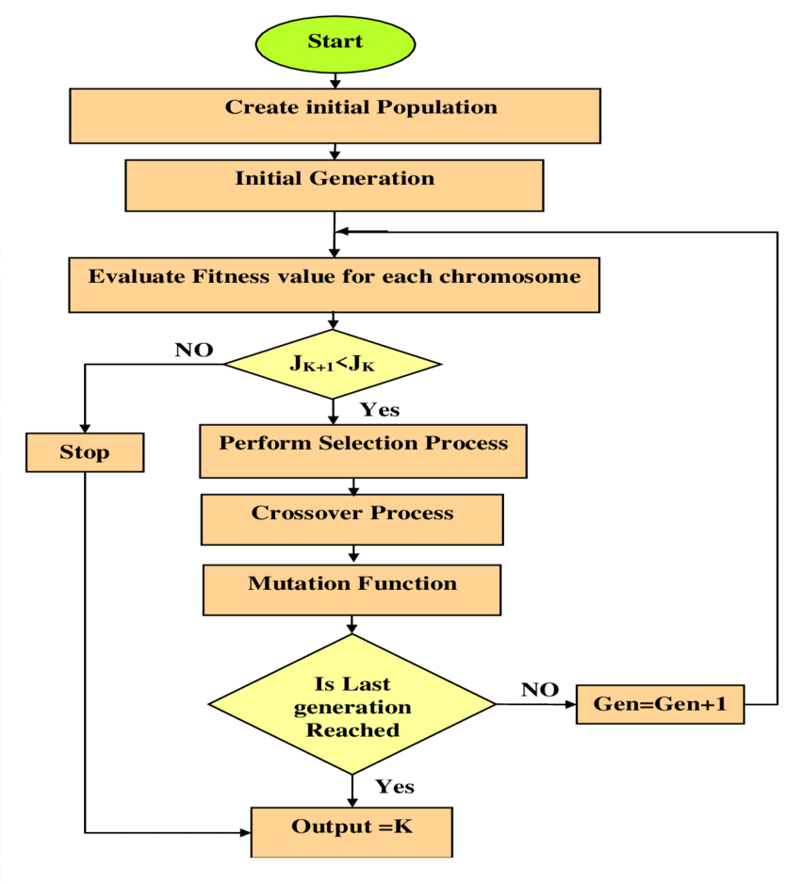

Prospective Users
OMG targets users who need to solve multi-objective problems in specific fields. Users have to map the solution spaces of the problems into forms of chromosomes supported by OMG. After the encoding of a problem, the general GA can be adapted to solve the transformed problem by tuning some parameters. E.g., generation number, mutation probability, fitness function choice, parent selection method, cross over method, mutation method, etc.
After the selection of parameters, OMG automatically creates an object of GA and runs it. The result will be shown on the screen for inspection after GA stops. Users can try out different parameter combinations to get the best version of GA that fits their needs by simply altering a few lines of Python code, OMG!

System Architecture

Tunable Parameters
- generation number (default = 100)
- mating parent ratio (default = 0.5)
- mutation probability (default = 0.01)
- fitness function choice (default = weighted sum)
- parent selection method (default = random selection)
- cross over method (default = single point crossover)
- mutation method (default = random mutation)

Output
- last population: Show top individuals in last population.
- fitness diagram
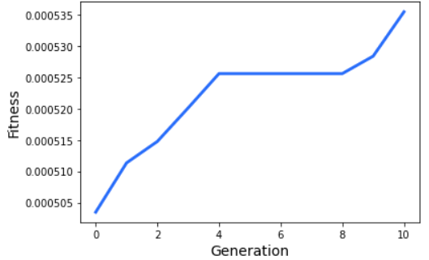

- new solution rate diagram

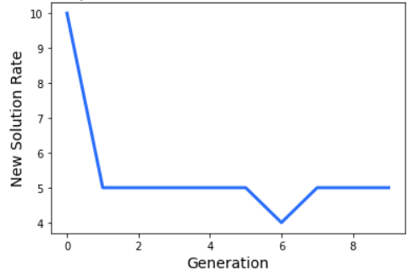

System Components
- Parser: Python class. Checks the validity of input parameters and performs necessary transformations.
- GA Wrapper: Python class. Wrapper class for underlying C++ GA class.
- Result: Python class. Contain results returned from GA wrapper.
- Printer: Python class initialized with Result. Responsible for printing the results in specified forms.
- GA: C++ class. Perform GA configured with parameters processed by parseParams.

System Workflow

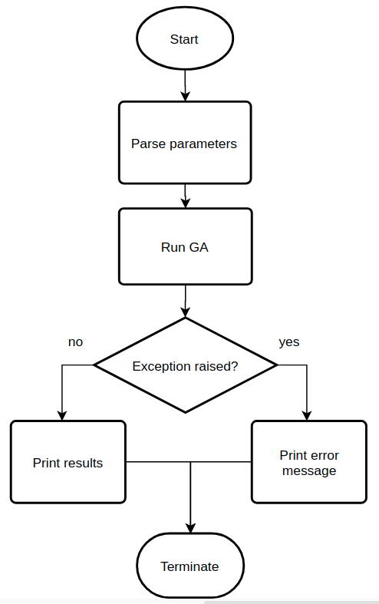
Assumptions & Constraints
- OMG supports double vector for gene representation.
- Some parameter choices make implicit assumptions. E.g., Roulette Wheel Selection and Stochastic Universal Sampling require fitness to be a positive value. Fail to meet the requirements may causes exceptions.
- OMG provides limited parameter choices, which may not be able to model a real-world problem properly.

API Description
API for Parser class
1. __init__(params: dict): Get the parameters from the user, checks the validity and performs necessary transformations. Raise exceptions if any check fails.
2. getParams() -> params: dict: Returns parsed parameters.

API for Printer class
- __init__(result: Result)
- printTopNum(num: int): print out the top num individuals in last population.
- printTopPercent(percent: float): print out the top individuals in last population.
- printFitness(): print out the fitness diagram.
- printNewSolutionRate(): print out the new solution rate diagram.

API for GA Wrapper class
  - __init__( params: dict): Create an instance of GA class with parameters provided by Parser class.
  - run() -> result: Result: Perform GA. May raise exceptions.

Engineering Infrastructure
Build System
make

Testing Framework
Python: pytest
C++: Google test

Version Control
git

Description
The Makefile contains commands to build C++ programs and run OMG along with several unit tests automatically. As for version control, there will be several branches:
- master: Tested, deployable version.
- fitness_function: Choices for fitness function.
- parent_selection: Choices for parent selection method.
- crossover: Choices for cross over method.
- mutation: Choices for mutation method.
- general_workflow: Code related to remaining functionality, includes Parser and Printer.

Schedule
- Week 1: Parser, Result and Printer.
- Week 2: General GA implemented with trivial methods.
- Week 3: More fitness function choices.
- Week 4: More parent selection function choices.
- Week 5: More parent selection function choices.
- Week 6: More crossover function choices.
- Week 7: More crossover function choices.
- Week 8: More mutation function choices.

References
[1] https://www.eng.auburn.edu/~aesmith/files/Multi-objective%20optimization%20using%20genetic%20algorithms.pdf
[2] https://github.com/ahmedfgad/GeneticAlgorithmPython
[3] https://www.researchgate.net/figure/General-flow-chart-for-GA_fig1_337199672
[4] https://pybind11.readthedocs.io/en/stable/classes.html

